Leverage dial gauge
一、Its characteristics are as follows：
- The resolution is 0.001mm and easy to read；
- The rigid outer frame is extremely stiff and durable；
- The clear, concise, large-diameter dial keeps the reading error within a reasonable range；
- Anti-magnetic pointers and styli for reliable use in magnetic environments；
- The lid is coated with an anti-slip coating；
- Outer frame material: 4CR13 steel, good stability for long-term use, no deformation and no rust; The probe is made of precious stones, and the wear resistance reaches 50,000 times。
二、The functions are as follows：
- Flatness detection；（2）Parallelism detection；（3）Perpendicularity detection；（4）Verify the accuracy of other instruments。
三、Flat graphics and dimensional specifications
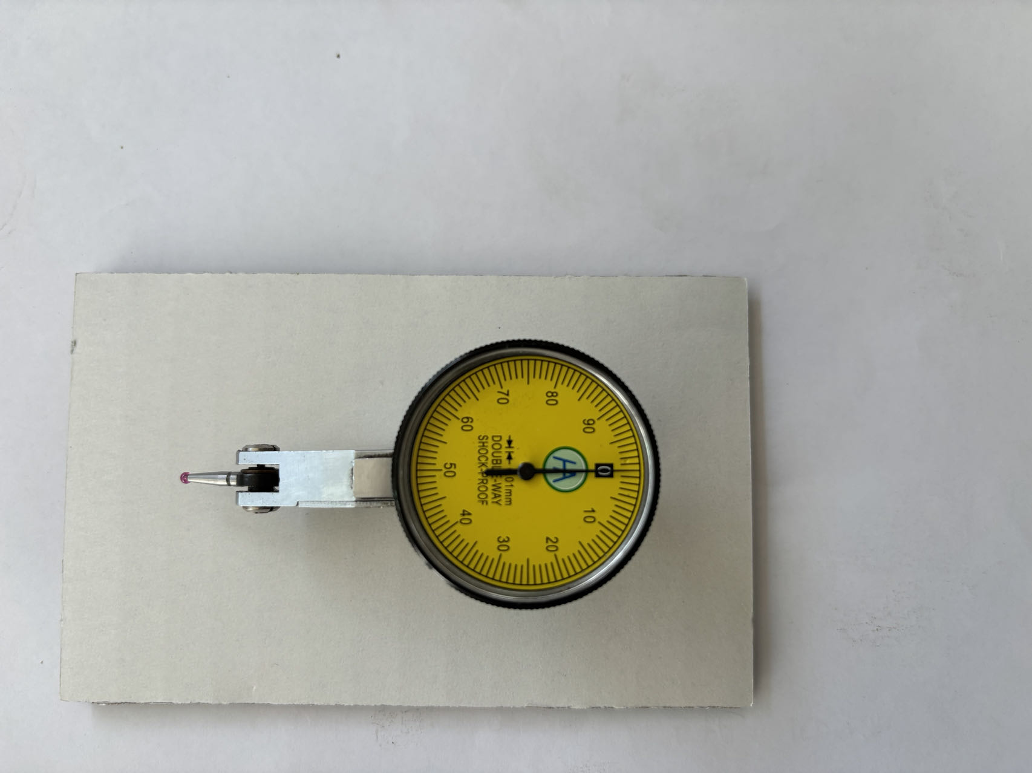

四、Measuring range and accuracy
Resolution and accuracy: The resolution is 0.001 mm, and the accuracy class is plus or minus 2 microns
code | Measuring range | Graduationvalue | Dial reading | 10scale accuracy（+/-） | Repeatability | Lap accuracy | Probe category | Weight (g)
2204 | 0-0.5 | 0.001 | 0-50-0 | 0.002 | 0.002 | 0.005 | ruby | 45kg
2205 | 0-1.5 | 0.001 | 0-50-0 | 0.002 | 0.002 | 0.005 | ruby | 45kg
2206 | 0-0.8 | 0.001 | 0-50-0 | 0.003 | 0.003 | 0.005 | ruby | 45kg
2207 | 0-1 | 0.001 | 0-50-0 | 0.003 | 0.003 | 0.005 | ruby | 45kg

